# **Azure Analysis Service**

This demo is to create Azure Analysis service in Azure and send data from local gateway where we have our Multidimensional Analysis project.

**Creating On-Premises Gateway**

To create an On-Premises gateway, go the following link and download Local Gateway installer and install it.

Link - <https://aka.ms/azureasgateway>

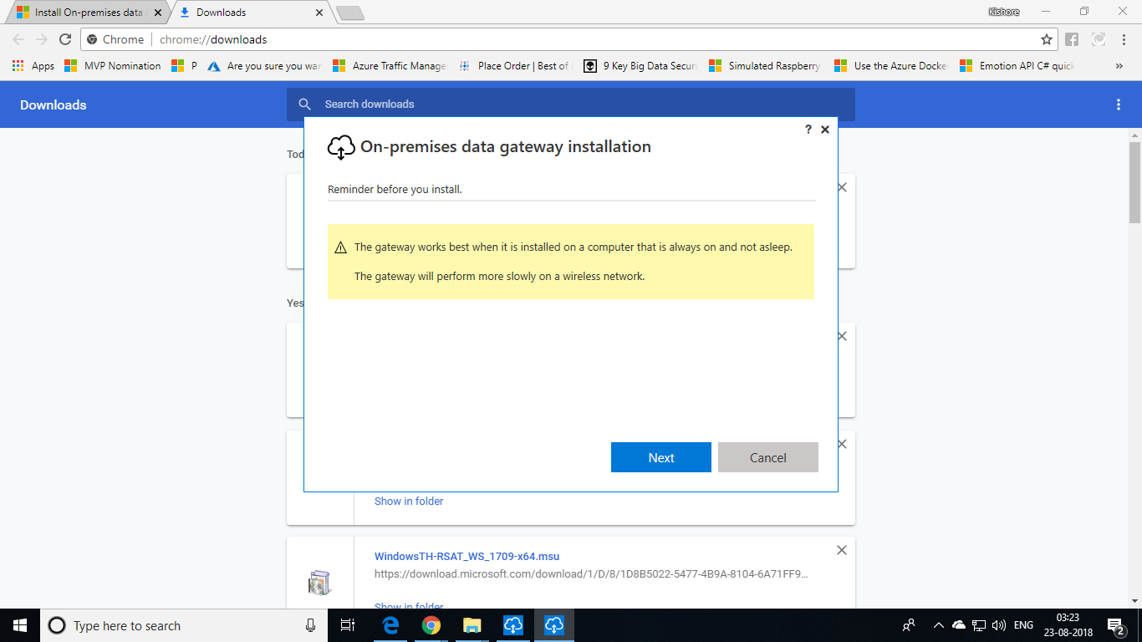

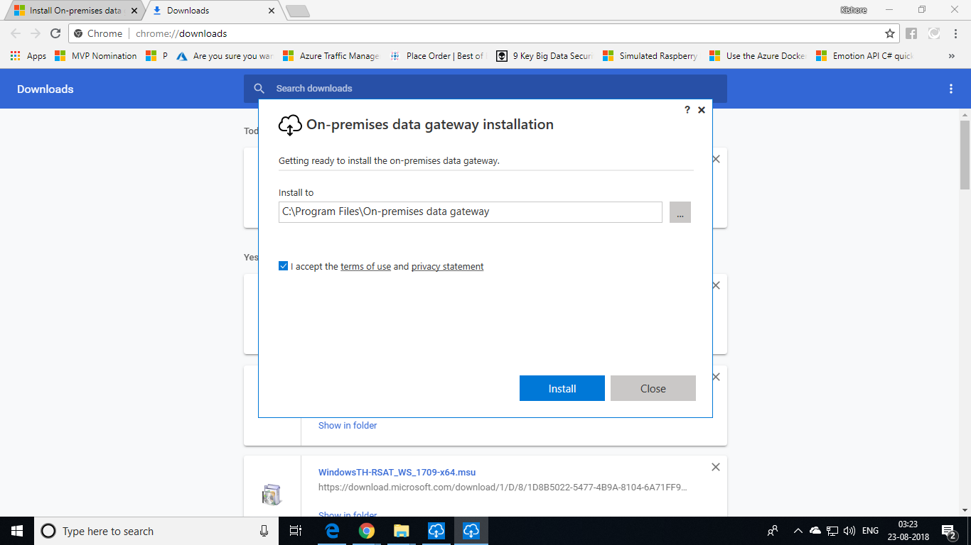

You will be asked to sign in. Use any tenant ID of your Azure account that has **Administrator** level access to your subscription. You cannot use your default mail ID and the password the you use to login into your Azure portal.

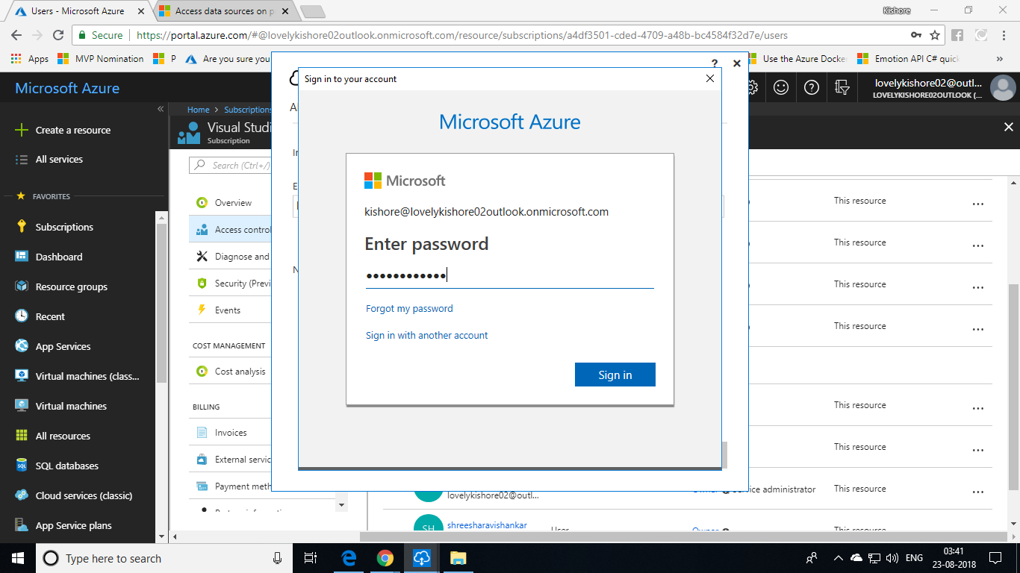

Give a name to your On-Premises gateway and give a recovery key and finally click **Configure.**

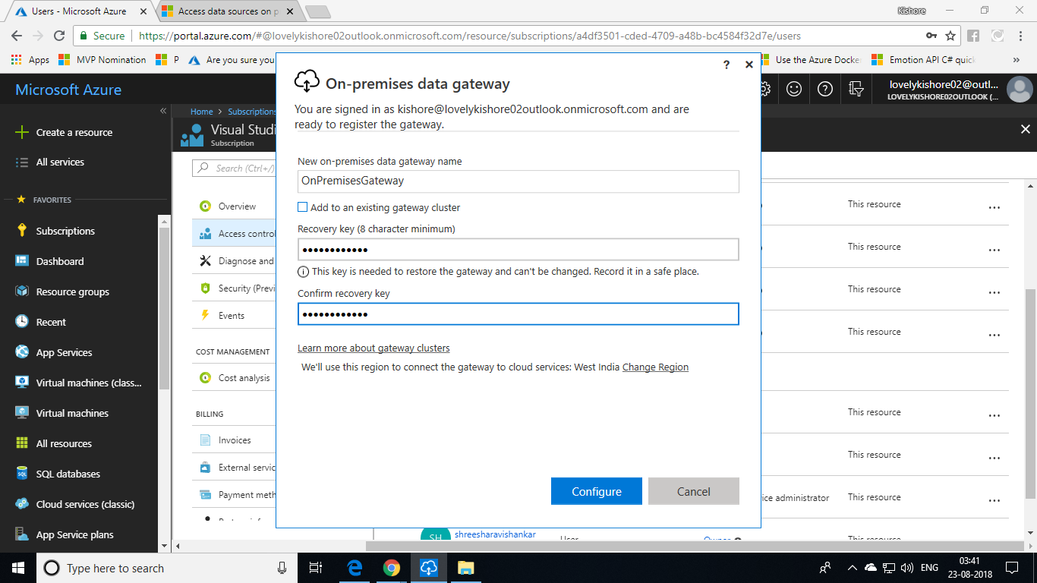

This will create your On-Premises gateway. Next, we have to create our gateway in cloud. Click the **Create Gateway in Azure** option for that.

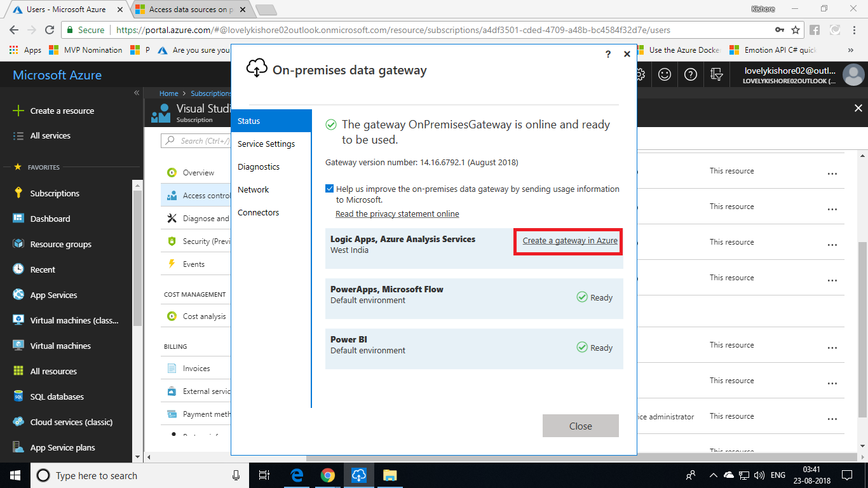

**Creating Gateway in cloud**

You will now be redirected into a browser to login into your Azure subscription. Make sure to login into your Azure subscription using the credentials that you gave while creating gateway in your On-Premises machine.

Give a name for the gateway, choose subscription, resource group. Make sure to choose the location that you choose while creating your on-premises gateway in your on-premises environment. At last, choose your On-Premises gateway for Installation Name and click **Create**.

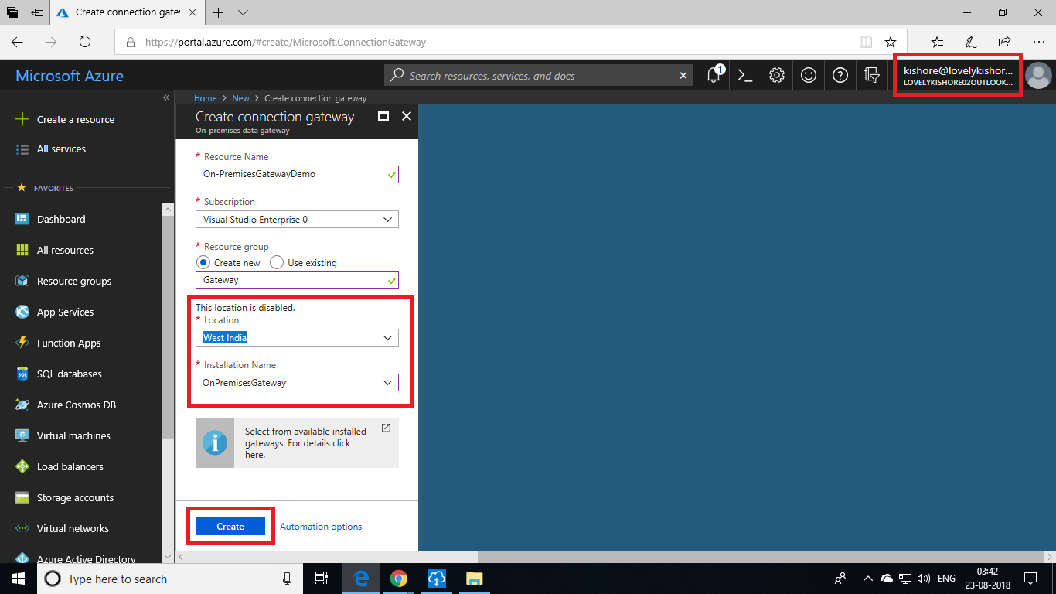

**Azure Analysis Service**

Now, let us create Azure Analysis Service to analyse out models. We shall deploy the project that we have developed so far into this service. To do that,

1. Go to **+Create a resource -> Analytics -> Analysis Services**.
2. Give an unique **Server** name. Select resource group and subscriptions.
3. Choose the same location in which you have created your gateway and finally click **Create** button.

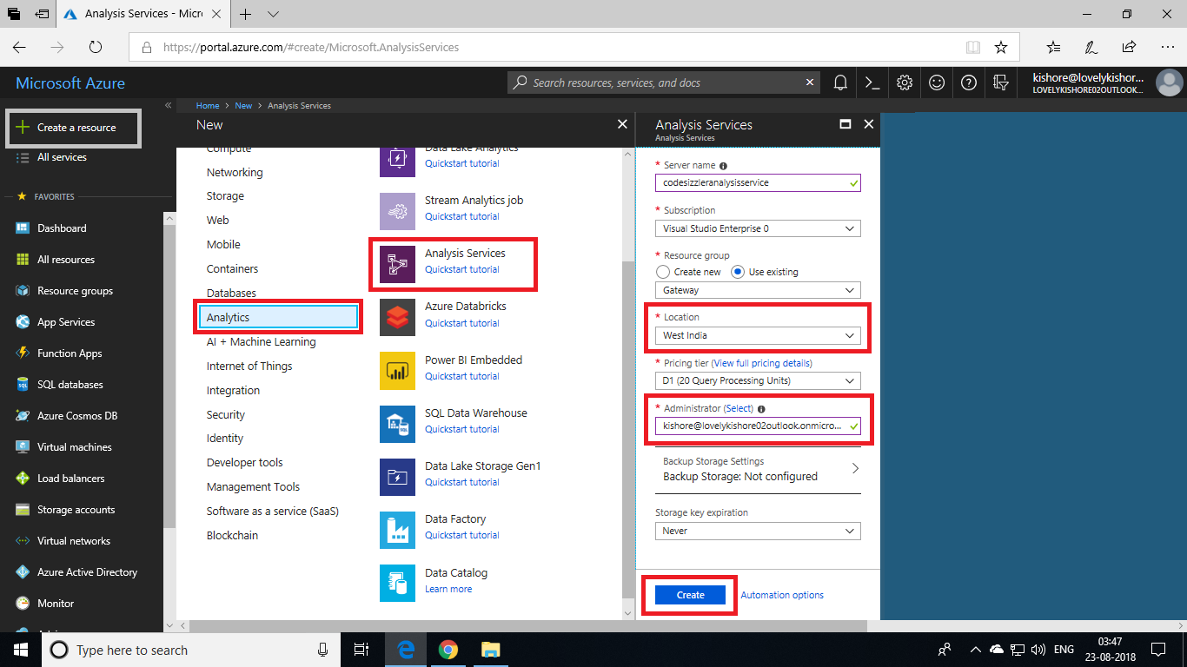

After the Analysis service gets deployed, go to **On-Premises Data Gateway** and select your region and your On-Premises Gateway. Now, click **Connect Select Gateway** option to connect your On-Premises gateway and **Azure Analysis Service**.

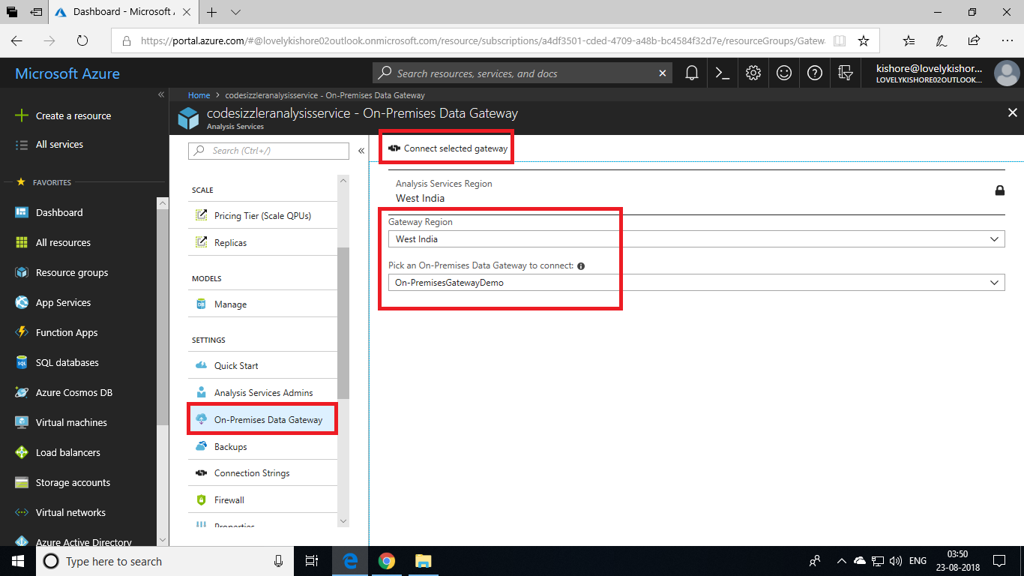

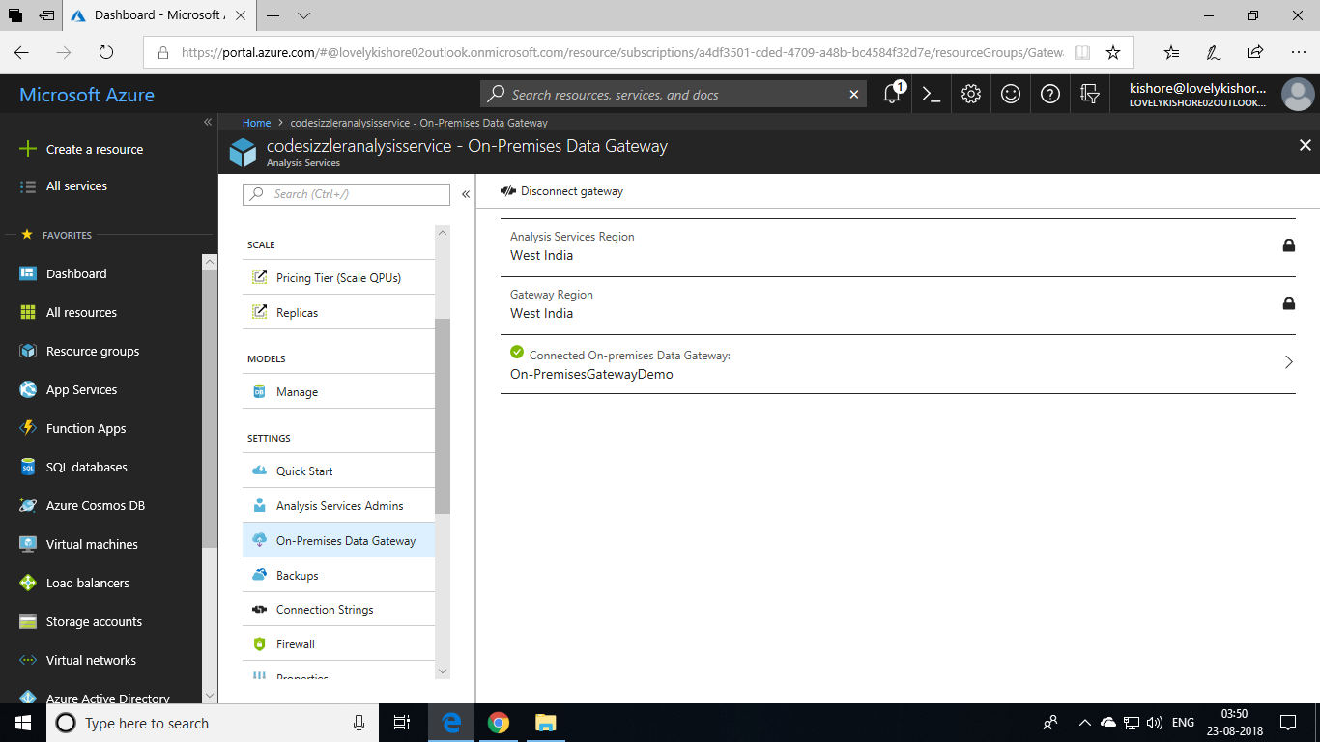

**Deploying Solution**

Now, we are ready with the solution that consists of tables, relations, partitions and roles. Let us try to analyse these now with the help of Azure Analysis service. To do this, go back to the **Visual Studio** and right click your solution and choose Properties.

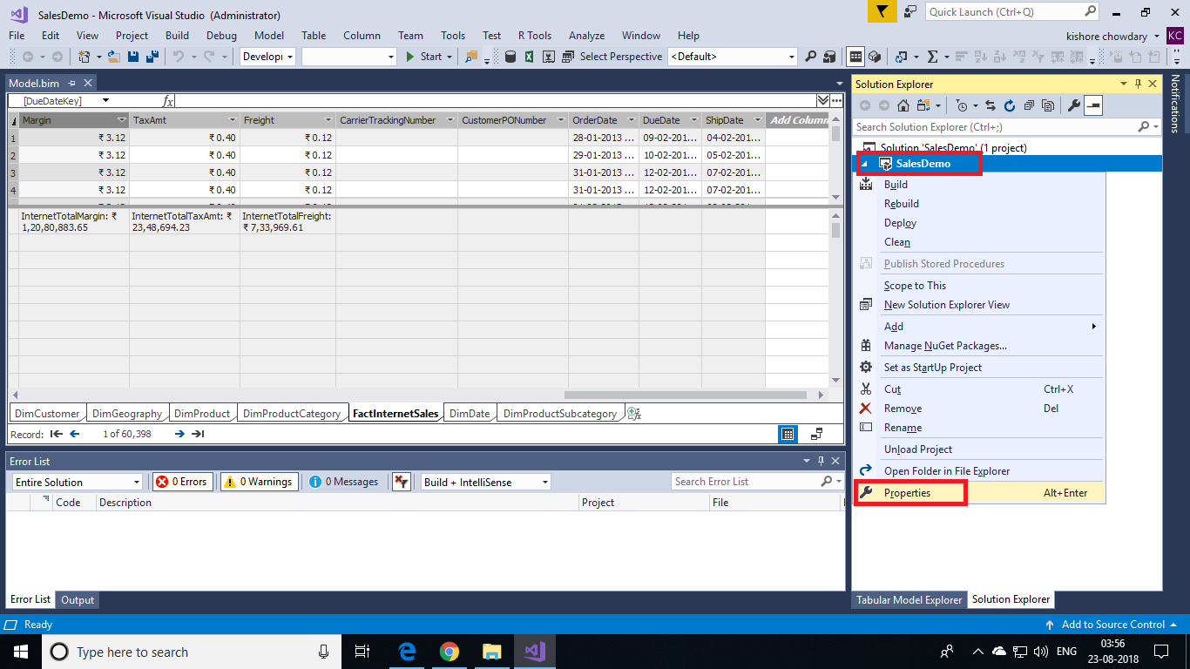

You will get a dialog box as shown below. In place of server name, paste the URL of your **Azure Analysis Server**. You can find this in the Overview page of **Azure Analysis Service** that you created previously. For database name, name it as **Adventure Works Internet Sales** and Model name as **Adventure Works Internet Sales Model** and then click on **OK**.

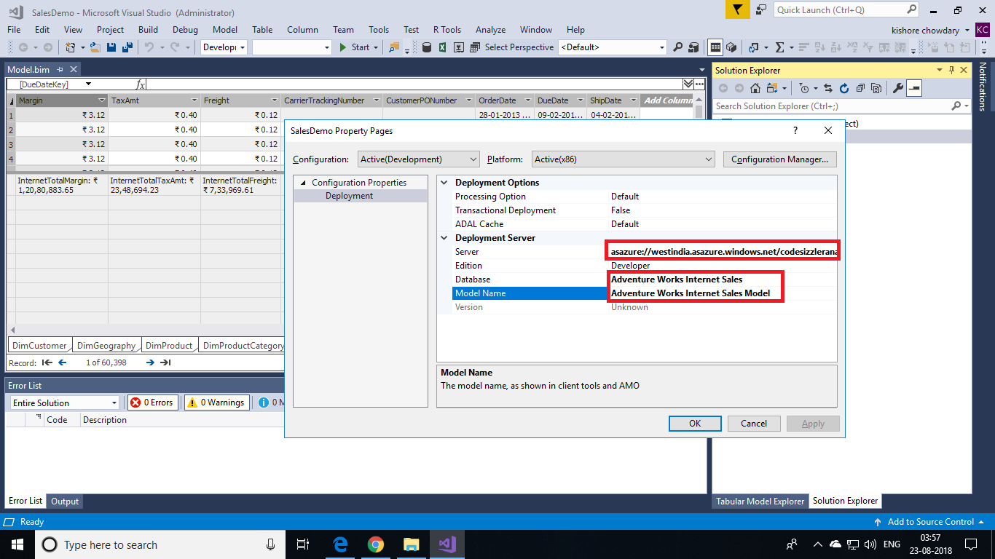

Now, we are all set to deploy the project. Click on the **Start** button or press **F5** button to deploy the solution into Azure Analysis Service.

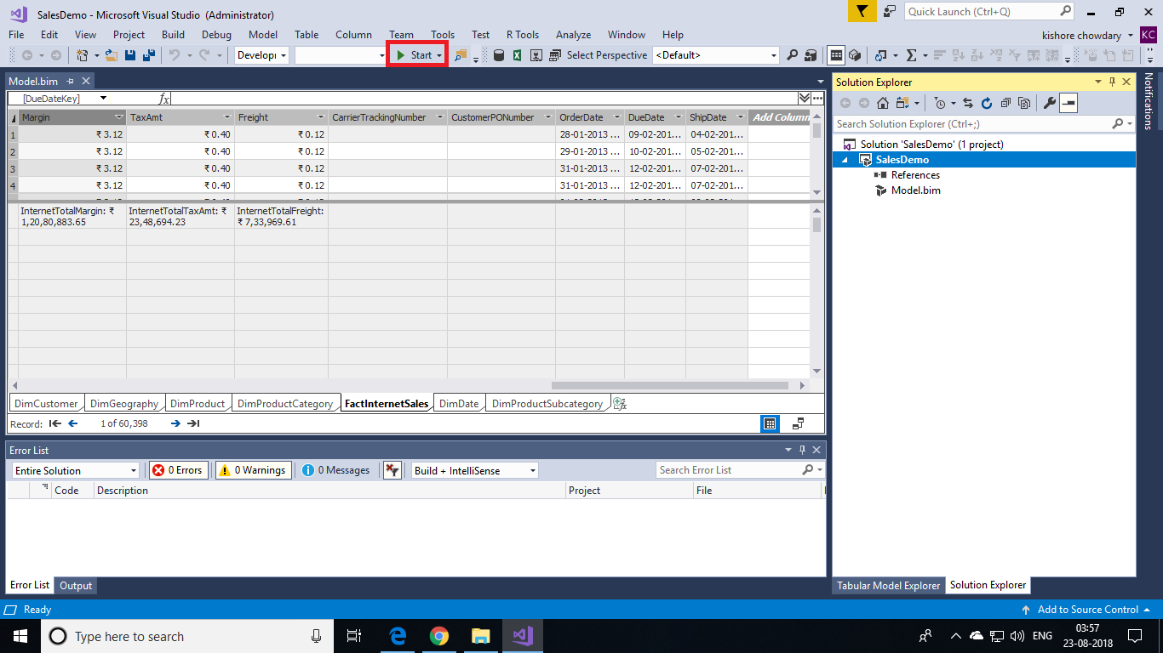

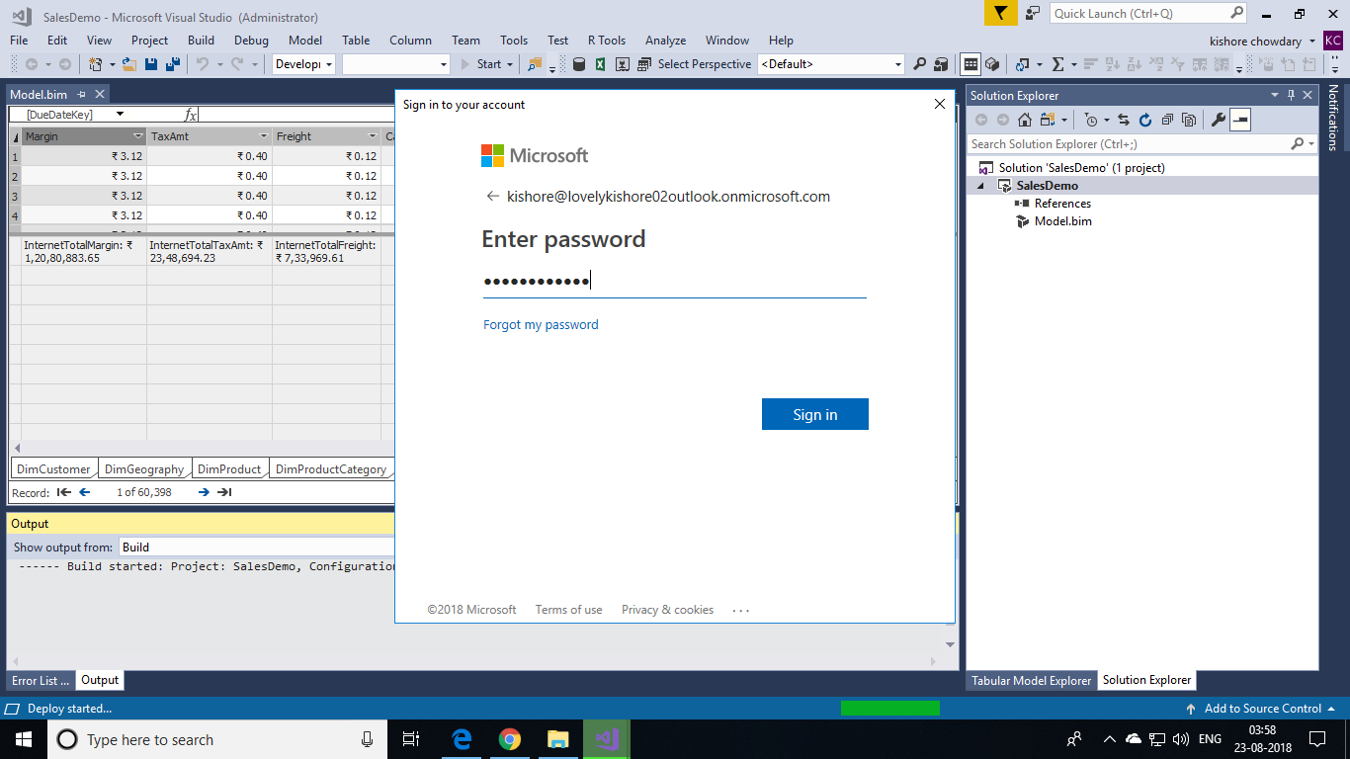

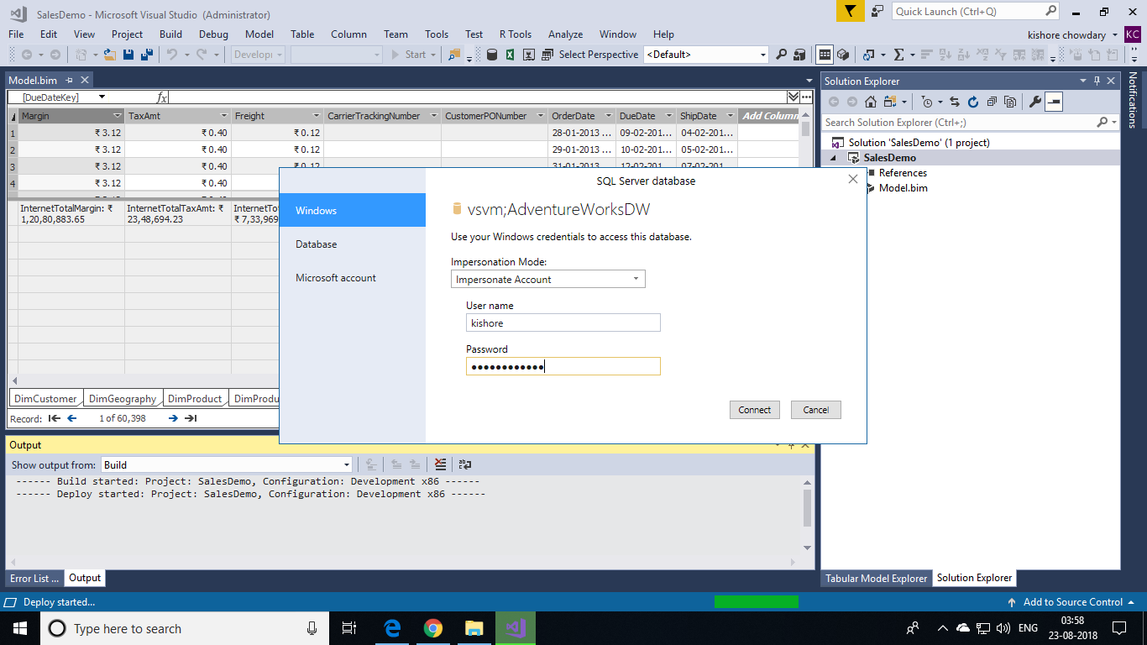

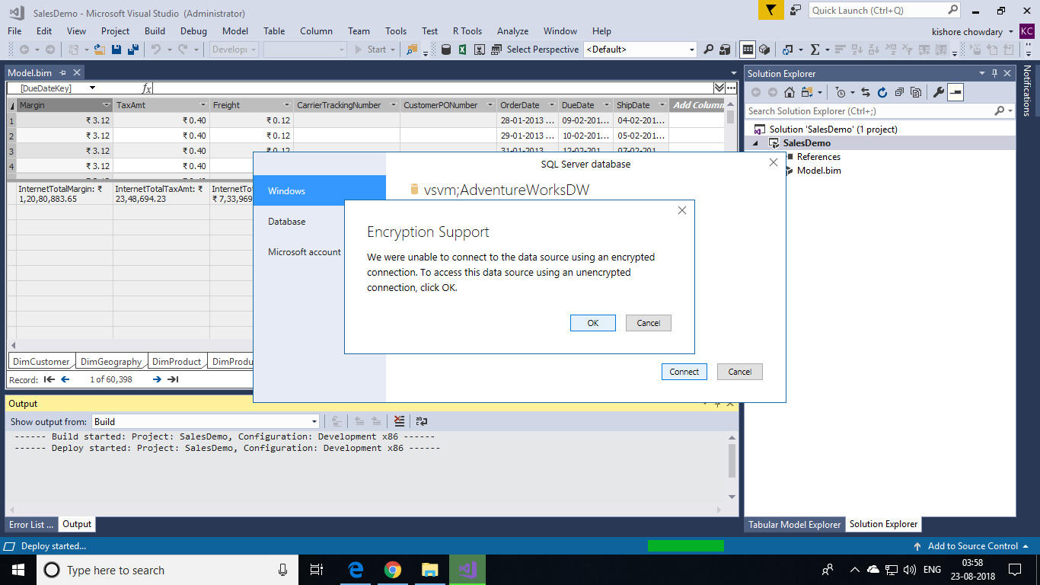

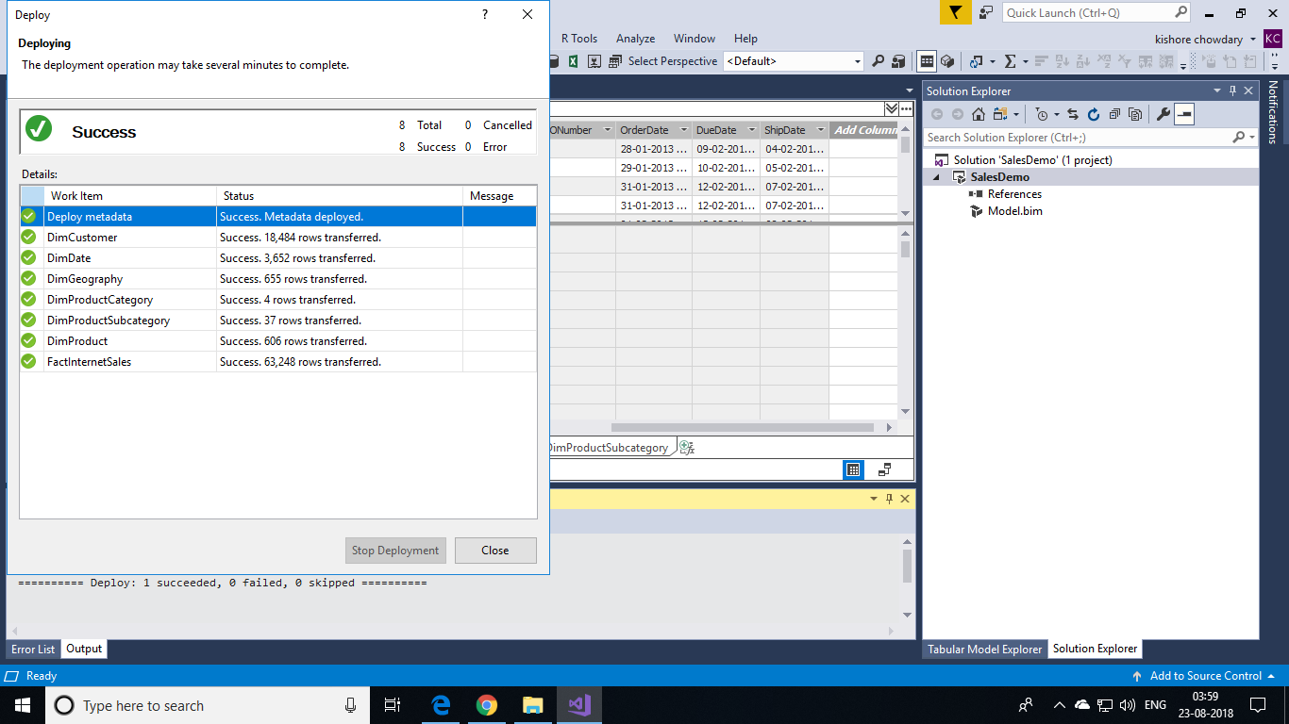

Now, find the Model in your Azure Analysis Service in Azure portal as shown below. There click on the Model and choose **Open in Web Designer.** You will get a new tab that shows your tables and their relations in diagrammatic view.

